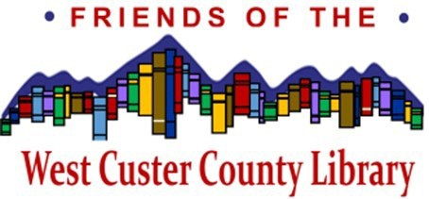

WEST CUSTER COUNTY LIBRARY FRIENDS 2026 MEMBERSHIP RENEWAL

Please take a moment to complete the following form and return it with your check for one of the following suggested levels, or whatever level of support you prefer. To renew online go to westcusterlibrary.org, select Friends of the West Custer County Library under the Support Your Library pull down. Remember that your membership renewal is a donation to the Friends of the Library and may be tax deductible.
Individual $20 Family $30 Other $_____
I/we enclose my/our check in the amount of $ for my/our 2026 membership in the Friends.

Name (s): Address:
City, State, Zip:

Email (please provide):

ELECTION OF FRIENDS OF THE LIBRARY BOARD MEMBERS

Please complete the following ballot of election of Friends of the Library board members. Each year three or four board seats are up for renewal. The ballot must be received prior to the annual meeting date of May 6, 2026. You may vote to elect all or a portion of the slate suggested by the Friend’s Board nominating committee. If you would like to suggest people for future board positions, please add their names and contact information to the back of this page.

Individual members are entitled to one vote for each seat. Family memberships are entitled to two votes for each seat.

Seat #1 Seat #2 Seat #3

Diane Dudley
Elizabeth Young
Polly Miller

Please mail your ballot and membership renewal to:

WCCLF, P.O. Box 1524, Westcliffe, CO 81252
Or just drop it off at the Library

